1. What does RGBA stand for?

**Answer :**

An RGBA color value is an extension of RGB i.e. Red, Green, Blue with an Alpha channel (opacity).

2. From the Pillow module, how do you get the RGBA value of any images?

**Answer :**

By getdata() function.

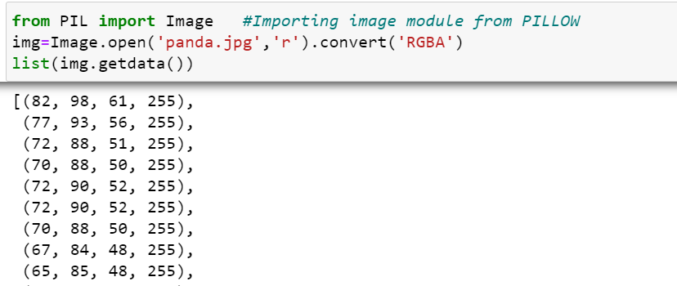

3. What is a box tuple, and how does it work?

**Answer :**

A box tuple is a tuple of four integer coordinates that represent a rectangular region in an image. The four integers are:

1. Left - The x-coordinate of the leftmost edge of the box.
2. Top - The y-coordinate of the top edge of the box.
3. Right - The x-coordinate of one pixel to the right of the rightmost edge of the box.
4. Bottom - The y-coordinate of one pixel lower than the bottom edge of the box.

e.g. Box tuple (3,1,9,6)

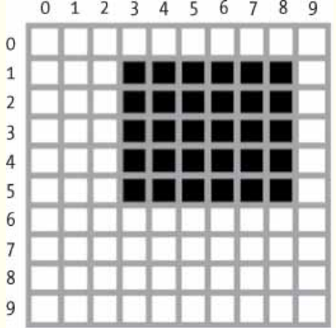

4. Use your image and load in notebook then, How can you find out the width and height of an

Image object?

**Answer :**

display(img)

print(img.size)

OR

print(“Width= “,img.width)

print(“Height= “,img.height)

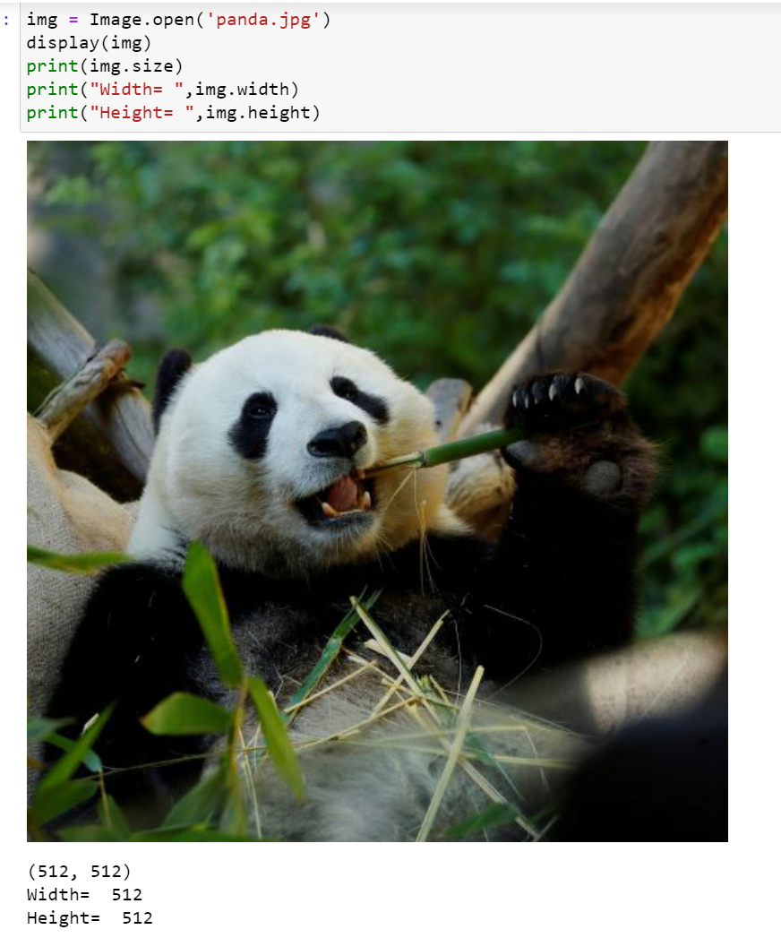

5. What method would you call to get Image object for a 100×100 image, excluding the lower-left

quarter of it?

**Answer :**

Image.fromarray() method is used.

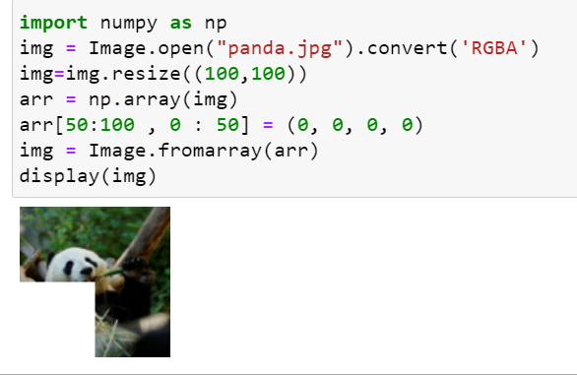

6. After making changes to an Image object, how could you save it as an image file?

**Answer :**

img.save() method is used to save image in .png/.jpg format.

7. What module contains Pillow’s shape-drawing code?

**Answer :**

The 'ImageDraw' module contains Pillow’s shape-drawing code.

8. Image objects do not have drawing methods. What kind of object does? How do you get this kind

of object?

**Answer :**

Imagedraw object has drawing methods. We can get this method by importing ‘imagedraw’ from PIL module.